Software Requirements Specification
for
The Planimeter
Version 1.0

Prepared by
Group Name: PS17-04(Group 4)
KAGAME STEVENLUC | 16/U/5127/PS | kagamelucky@gmail.com
LUKYAMUZI BENON | 16/U/6673/EVE | lukyamuzibenon@gmial.com
KARUHANGA LINCOLN | 16/U/5465/PS | karuhanga475@gmail.com
OLUMA RODERICK | 16/U/10985 | rod2luma@gmail.com

Mentor:
Course: | CSC 1304 Practical Skills Development
Date: | 17th July 2017

Table of Contents
1Introduction 4
1.1Document Purpose 4
1.2Product Scope 4
1.3Intended Audience and Document Overview 4
1.4Definitions, Acronyms and Abbreviations 5
1.5References and Acknowledgments 5
2Overall Description 6
2.1Product Perspective 6
2.2Product Functionality 7
2.3Users and Characteristics 8
2.4Operating Environment 9
2.5Design and Implementation Constraints 9
2.6User Documentation 10
2.7Assumptions and Dependencies 10
3Specific Requirements 12
3.1External Interface Requirements 12
3.1.1User Interfaces 12
3.1.2Hardware Interfaces 12
3.1.2.1Interaction with the GPS component 13
3.1.2.2Interaction with the Accelerometer 13
3.1.3Software Interfaces 13
3.2Functional Requirements 13
3.3Behaviour Requirements 14
4Other Non-functional Requirements 15
4.1Performance Requirements 15
4.2Software Quality Attributes 15
5Other Requirements 16
5.1Appendix B - Group Log 16

Revisions
Version | Primary Author(s) | Description of Version | Date Completed
#1.0 | Kagame Stevenluc  Lukyamuzi Benon  Karuhanga Lincoln  Oluma Roderick | Version 1.0. is the initial rollout version of the plainimeter | 14/07/17

Introduction

Document Purpose
    - The product is a mobile application that will enable users to measure the area of a piece of land that the are mapping and this document is specifically for the rollout version of the product (version 1.0)

Product Scope
    - The Planimeter is a mobile application that when completed will provide the functionality required to estimate the area of a plot of land. Currently available methods require an individual to hire land surveyors that use specialized equipment like Theodolites to make recordings and later calculations based on the recordings. These methods are tedious, especially considering the fact that the majority of people seek only an estimate of the size of a plot to make quick decisions. The application seeks to provide an intuitive, affordable, quick, efficient and reasonably accurate method to help users make this estimate.

Intended Audience and Document Overview
This document is intended for the course facilitator as well as the group members for the purpose of giving the course facilitator a general over view of what the project is about as well as enable the group members who herein are the developers have a general form of reference and guidance throughout the development process
For a better understanding, it is advisable the facilitator reads the document in the order it is presented without skipping anything

Definitions, Acronyms and Abbreviations
GPS- Global Positioning System
3G- Third Generation
APP- Application

References and Acknowledgments
    - https://github.com/danielmurray/adaptiv
    - https://github.com/itkovian/StepCounter
    - https://en.wikipedia.org/wiki/Smartphone
    - https://en.wikipedia.org/wiki/Mobile_app
1.1.7 https://material.io/guidelines

Overall Description

Product Perspective
The system will consist of a newly developed mobile application that will be installed on the user’s device. It will make use of two of the device’s sensors, the GPS component, which will track a user’s position at various points along the boundaries of the plot and the Accelerometer which will provide data that will be used to approximate movement, that is footsteps. These components are included in nearly all smart phones currently available on the market.
In as much as the technology utilized by smart phones has come a long way, the devices still don’t have the capability to understand their environment which hinders functionality like independently using the devices to take measurements and track movement.
The system will therefore utilize the data from the above-mentioned components as well the google maps application and achieve the objective without the need for pre-calibration and other types of pre-sets to approximate the area between the calibrated points basing on a reliable heuristic.
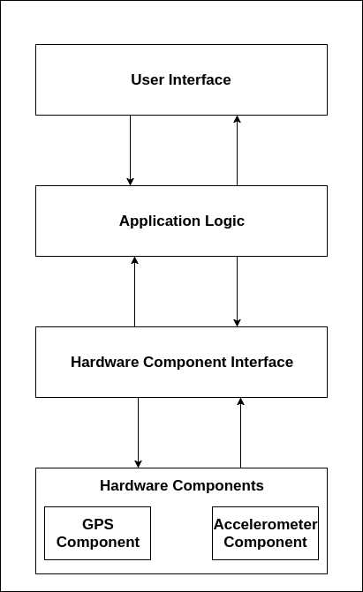
2.1- Operating Environment for the System

Product Functionality
The application must let the user measure the length of a plot boundary and calculate the area of a plot. This process will include;
- Taking GPS readings and measuring distance between two recorded points
- Take Accelerometer readings and approximate walking behaviour
- Generate approximation of plot layout
- Calculate the area of a plot based on this recorded data
- Store saved calculations
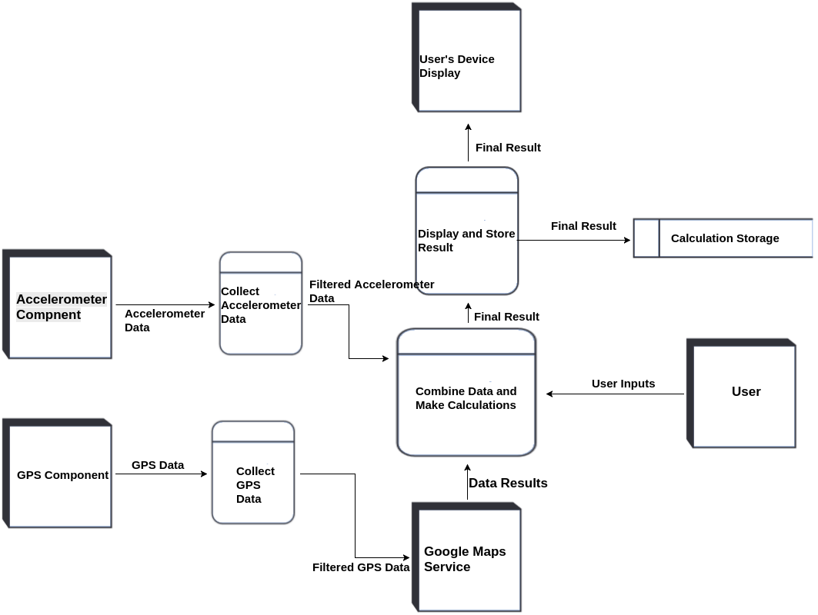
2.2- Level 1 Data Flow Diagram for the System

Users and Characteristics
The system is designed and developed targeted towards users from any background that have basic knowledge of how to utilize a smart phone. The product does not come with any need for technical expertise, as that is the problem it seeks to solve.
Any individual with the need to measure the area of an expanse of land can therefore easily make use of the application.
It will however be of frequent use to people whose work regularly requires this use case. These may include real estate agents, brokers, building contractors, prospective land owners and real estate investors.

Operating Environment
The rule for selecting hardware and software is that components of the application must be functionally efficient, capable of interfacing with other software if required to in the future and easy to maintain.
The following table displays a summary of the system’s operating environment.
Specification | Requirement
Hardware Platform | Smart phones or Tablet devices that fit the following criteria;  - Have inbuilt GPS and an Accelerometer
Device Operating System | Android OS, minimum Android 4.1- Kitkat

As will be indicated in the specification details, the system will not have any other dependencies and is also not expected to interfere with the smooth running of any of the other software on the device.
The minimum software requirements chosen are influenced by the fact that low end devices running this version had the first widely adopted support for GPS in Android.
Please refer to the diagram as in 2.1- Product Perspective

Design and Implementation Constraints
The biggest challenge the project is faced with is the fact that low-end android devices which are the kind commonly used on the continent lack the more advanced sensors such as the step sensor. This has therefore necessitated the creative use of the available sensors, which may not produce results as accurate as the above mentioned sensors.

In addition to this, the team faces the following implementation constraints;
- The availability of devices with both GPS and Accelerometer hardware components is not guaranteed. This necessitates the design of each system independently and later combining the results of data from both components, such that in the event that one of the components is not available for any reason, the other can function independently, albeit not as accurately.
- Difficulty of access to a wide range of android devices for testing the system, coupled with lack of appropriate devices to run the required emulators.
- The system will make use of the GPS component that is widely known for its power drain especially on low end devices. Developers will therefore have to ensure the efficient use of this component, especially in light of the fact that both hardware components will be in use at the same time if available.
- In order to ensure accurate GPS readings, devices require internet access which is not a guarantee in some areas.
- Design for minimal future maintenance. In order to reduce technical debt that might be incurred in the future, the team will need to ensure that all components included the system are resilient and easily improvable and/or interchangeable if the need arises.
- Where feasible, developers are expected to follow Android design guidelines, which include but are not limited to following material design principles and efficient memory use.

User Documentation
As previously mentioned, the system is developed with non-technical and non tech-savvy people in mind. The system is targeted towards smart phone owners who have the knowledge of basic application usage.
However, for the totally unacquainted, the team can be reached on social media, email and telephone. Wikipedia also offers excellent resources in this case, the links of which are provided in the appendix.

Assumptions and Dependencies
The following are the most sensitive assumptions, whose change would have significant impact;
- As mentioned in the software requirements, the project will make use of two, non-proprietary software components. Since these are open source projects, they are subject to change at ay time ad there is no guarantee that functionality will still be maintained after the change.
- The project’s use of the GPS component also necessitates the availability of a reliable internet connection during recordings to achieve the best accuracy possible.
- Readings taken from the user’s device can only be as good as the sensors embedded in the device. Inaccurate readings due to faulty sensors or otherwise may in turn produce inaccurate results.
- The software will depend on the availability of both sensors for utmost accuracy. Absence of either may significantly reduce the accuracy of readings.
- Lastly, user cooperation is expected, especially because their input will be required when taking accelerometer readings. Inaccurate input will in turn produce inaccurate results.

Specific Requirements

External Interface Requirements

User Interfaces
Team members will follow material design principles and guidelines wile developing the application. Consistency should be maintained across devices. Samples of major interfaces are provided below.
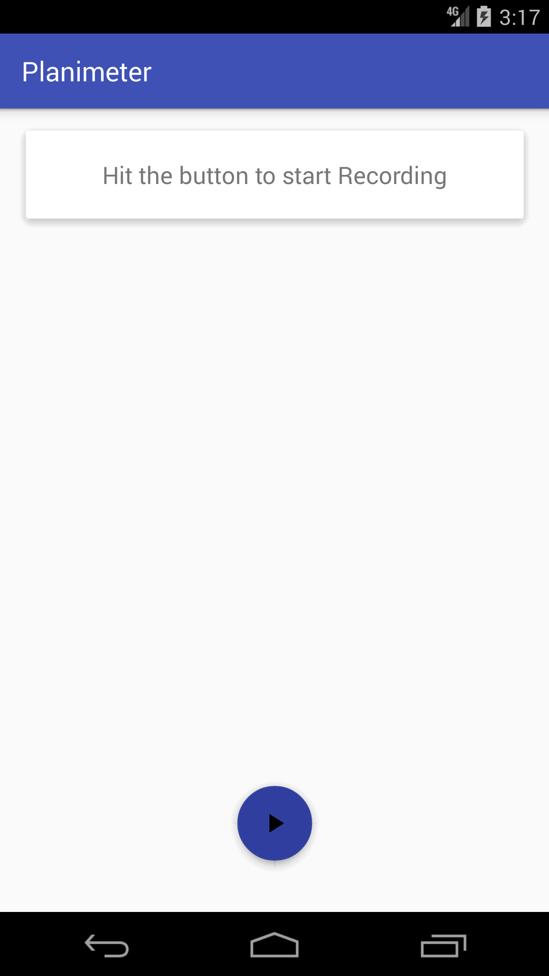 | 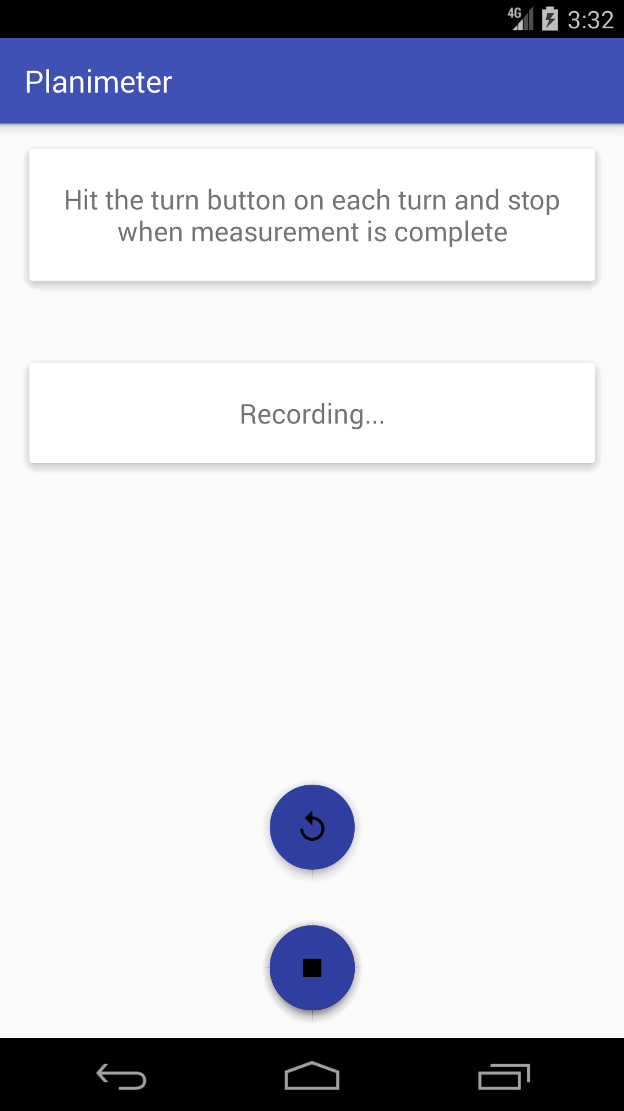 | 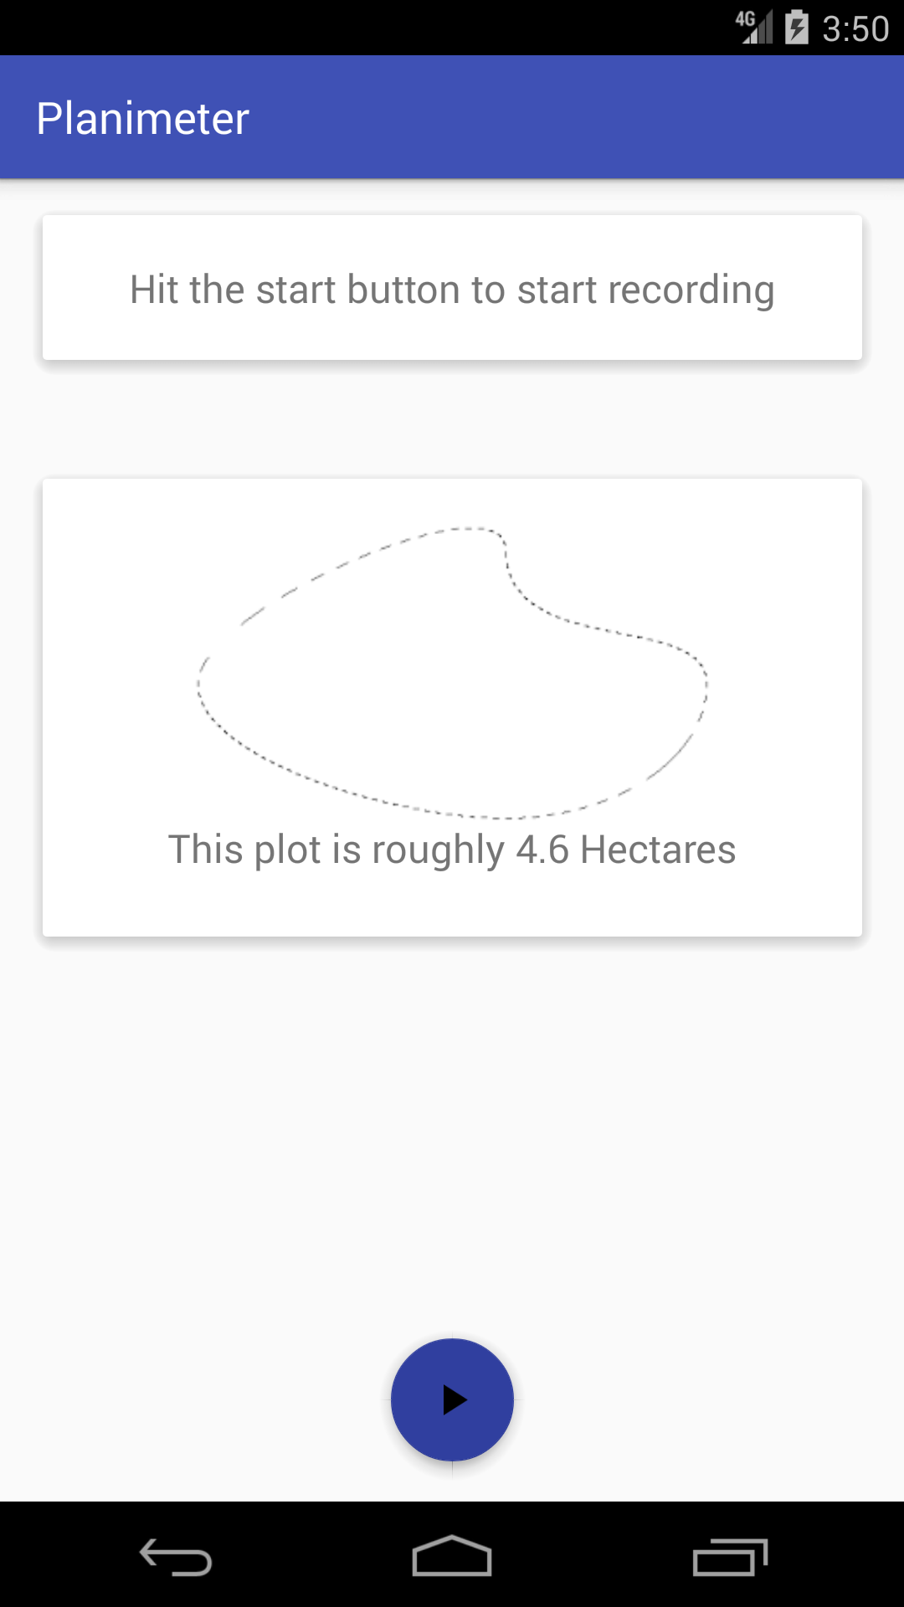

Hardware Interfaces
The proposed mobile application does not have any designated hardware required for its operation and it therefore does not have any need for direct hardware interfaces.
However, the application will interact with the device’s physical GPS and Accelerometer components which are both natively managed by default by software components built into the android platform.

Interaction with the GPS component
Interaction with the GPS which involves making location data requests and receiving data readings from the GPS component. The android platform provides a software component, Location Manager to allow developers access the GPS component.

Interaction with the Accelerometer
Interaction with the accelerometer involves making repeated calls to the devices accelerometer sensor and get readings which are then run through algorithms to put them into context and then take actions based on the readings. Access to this component is done via the Sensor Manager which allows developers access this data.

Software Interfaces
As previously mentioned, the application will be developed for the android platform. The team will make use of the default recommended software components for the android platform.
In addition to these, the project will make use of two software components previously implemented and hosted on github.com under a free to use license by Daniel Murray and It Kovian, the links of which have been provided in the appendix. Both projects implement unique ways of taking accelerometer readings and applying filtering algorithms that have a final result of isolating noise, that is non-required recordings from the accelerometer component and therefore make it easier to identify movement, i.e. footsteps, which is the intended use for the Accelerometer in the project.

Functional Requirements
    - User Initiates the App; this mainly involves the user clicking on the application icon to start the application
    - In a scenario where the user has both GPS and an accelerometer on their device, all they will have to do is start walking around the piece of land they intend to measure while clicking on the turn right or left button respectively and when they are done, they should click ok to see the area of the land
    - When done, results can be viewed and saved
    - The user can also decide to view the calibrated piece of land on Google maps

Behaviour Requirements

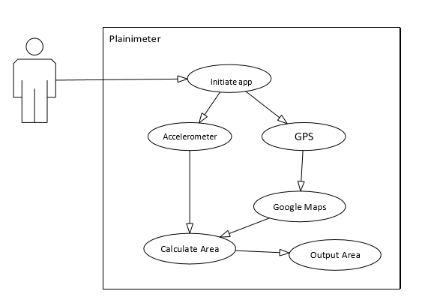
3.3 Use case diagram for the planimeter app

Other Non-functional Requirements

Performance Requirements
    - Response Time: the application’s response time will majorly depend on the internet connection provided all the underlying requirements are met as specified in this document. The connection threshold is a 3G internet connection which will guarantee a response time of under 30 seconds after the calibration is done
    - Workload: the application will only be able to support a single user at a time with the ability to only take one measurement at a time
    - Scalability: Since the application is a not a cloud based application, scaling will only be limited to supporting extra features as opposed to supporting many users, such features may include but not limited to the ability to calculate surface area, aid in land planning and so on.

Software Quality Attributes
    - Availability, the app will always be available to the user at any time and can be used at the convenience of the user’s need
    - Portability, unlike other land measuring tools like theodolites, the app will be available at the convenience of a device’s portability
    - Efficiency, So you want to take a quick measurement of the land you intend to buy and make a quick decision, the app will efficiently offer you a quick way out. Based on tested technologies, you are guaranteed of efficiency when it comes to measuring your land the smart way

Other Requirements

Appendix B - Group Log
8.1.1 Team meeting minutes attached below

SYSTEMS REQUIREMNETS MEETINGS HELD ON 10/7/2017 HELD AT CIT BLOCK B
Members present:
Lincoln Karuhanga
Benon Lukyamuzi
Kagame Stevenluc
Oluma Roderick

Agenda:
1.Opening prayer
2. Brain Storming of ideas
3. A.O.B
4. closing prayer

MIN 1 OPENING PRAYER
Oluma led the team through an opening prayer

MIN 2 SRS MEETING. BRAIN STORMING
Oluma suggested using the phone camera to take pictures and then having a way of processing the images to determine the area of the piece of land in question
Lincoln however argued that such an approach would have serious inconsistencies with accuracy and that the image processing alone would be close to impossible implementing it on a phone.

MIN 3 SRS MEETING BRAIN STORMING
Lincoln suggested that we use the phones built in GPS and accelerometer to keep track of the users position while the traversed the piece of land to measure.
After which we will come up with an algorithm to measure the demarcated piece of land

MIN 4 SRS MEETING BRAIN STORMING
Benon however argued that coming up with the link would be reinventing the wheel, and instead suggested that the data collected should be mapped onto google earth or google maps application and use their built-in services of calculating the area of the demarcated piece of land

MIN 5 SRS MEETING A.O.B
Kagame suggested using both the gyro sensor and the accelerometer to improve on mapping accuracy.
This was however argued by Benon as employing two resources to accomplish a task that can be done by one resource
MIN 6 SRS MEETING A.O.B
Oluma asked for the difference between a gyro sensor and an accelerometer which Lincoln fully explained.

MIN 7 SRS MEETING CLOSING PRAYER
Kagame led the team through a closing prayer and the meeting was adjourned at exactly 2:30 PM

  - Pre-Initiation requirements
8.2.1 Its is required that the user ensures they have a reliable 3G internet connection and a good battery percentage as the application utilises functionalities like GPS that are a quite battery intensive

